# Parking System

**Abstract**

It is highly needed to maintain and upgrade those all things which are widely use in our personal and professional life. The Parking system is very much annoying at this time but the smart is defined as the eco-friendly as well as perfectly digital city in all the aspects. The report is all about the smart city and smart parking system with the time saving facilities and better safe and secure environment using certified data by Parking System .This is really necessary to open each and everything about the new smart city which will be our next life. So, this report has each and every thing in very clear way. The system of smart parking and smart city is reliable up to at what point is showing in this report how the infrastructure work together.

**Introduction**

The role of parking spaces in the transportation system is vital. Every vehicle making a trip needs a parking space at its origin and destination, regardless of the parameters defining the trip. Various systems of managing and controlling parking have been applied since the beginning of the 19th century worldwide. The hectic schedule of the parking and their space is really irritable at all the time especially in commercial areas. The one of the main problem is that, there are plenty of increment in the motor field but not in parking space as it should be. It is highly needed to maintain and upgrade those all things, which are widely, use in our personal and professional life. The Parking system is very much annoying at this time but the smart is defined as the eco-friendly as well as perfectly digital city in all the aspects. The report is all about the smart city and smart parking system with the time saving facilities and better safe and secure. This is really necessary to open each and everything about the new smart city which will be our next life. So, the smart Parking system is really just like the revolution in the world of parking, which is able to save time and make each and everything reliable. The one of the best things is that, it is the most convincible way in this high population. The main thing is that, we can use our all kinds of gadgets to protect our vehicle, make our life reliable and safe as well as to make the schedule time saving. The one of the best things is that, it is really amazing to have each and everything quick and fast without making any trouble. The term smart city is widely using now a days as it is becoming the basic needs for the entire world. The life at this time is truly fast and furious at all the time. In this fast and furious era, we need each and everything reliable with the time saving and better result. The reliable transportation without any problem is the basic needs which can’t be fulfill without making the smart cities.

**User Stories**

1. As a new car owner, I would want to register with the system.
2. As a new car owner, I am interested in parking area information.
3. As a registered car owner, I would want to log in to the application.
4. As a registered car owner, I want to access parking area information.
5. As a registered car owner, I want to park my vehicle.
6. As a registered car owner, I want to pay the cost for a parked vehicle.
7. As a registered car owner, I would want to check parking history.
8. As a parking lot owner, I want to access parking area information.
9. As a parking lot owner, I want access to car parking history.

**Advantages of parking System**

1. It is more safe and secure because each everything is digital and fast.
2. It takes less area and gives more space to park then traditional parking.
3. It helps to secure the parking spot
4. It also helps to avoid parking tickets in the cities
5. Users can get details about parking areas for particular locations.
6. It saves user time in search of parking space available in such a long parking area.
7. The system provides a view of the parking spaces.
8. It excludes the need of human efforts for managing parking spaces.

**Methodology**

Parking owners need to register to the system so that they can see page with parking locations. After registering with the system owner should login to the page and access the given information where they wanted to park the vehicles at the areas provided after entering the details, they can pay the fee and register the spot for the time which they are paid for and they can view their parking history By the image, can be known and used to guide a driver to a car park and proceed for the further steps. By implementing this system, the utilization of parking spaces will increase. It allocates available parking space to a given driver to park their vehicle, renew the availability of the parking space when the car leaves and compute the charges due. It is also help in search of the best possible path from the current position to the parking facility and then to the destination. So, the smart parking is one of the best way to remove the rush in the city rods and ways. This is easy and reliable along with the economical.

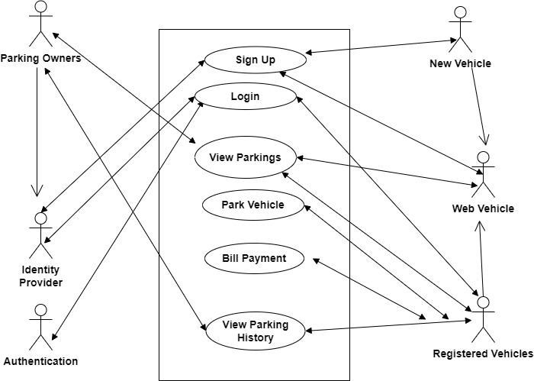

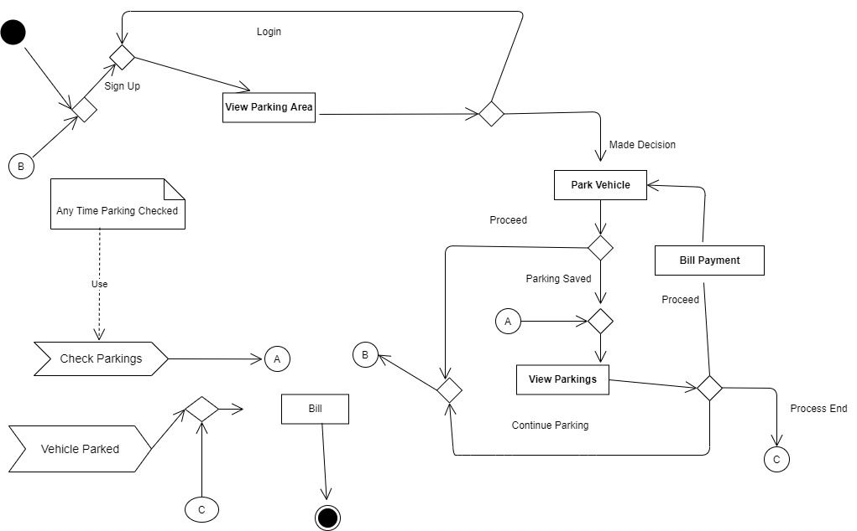

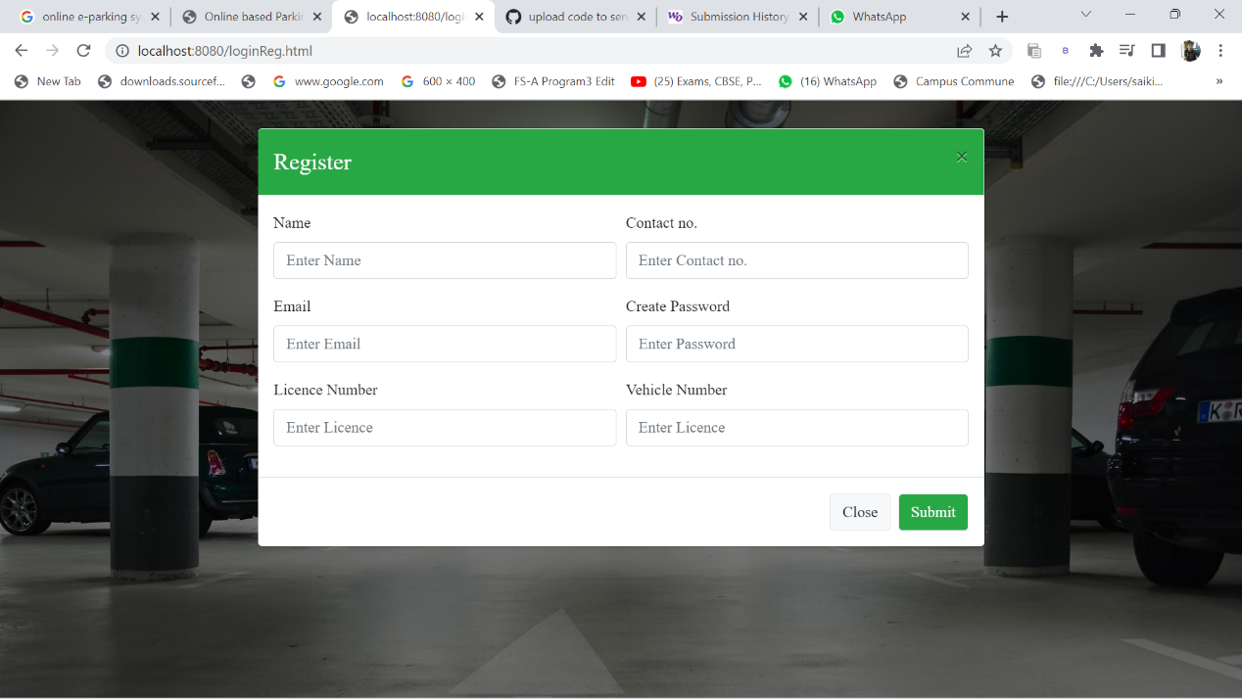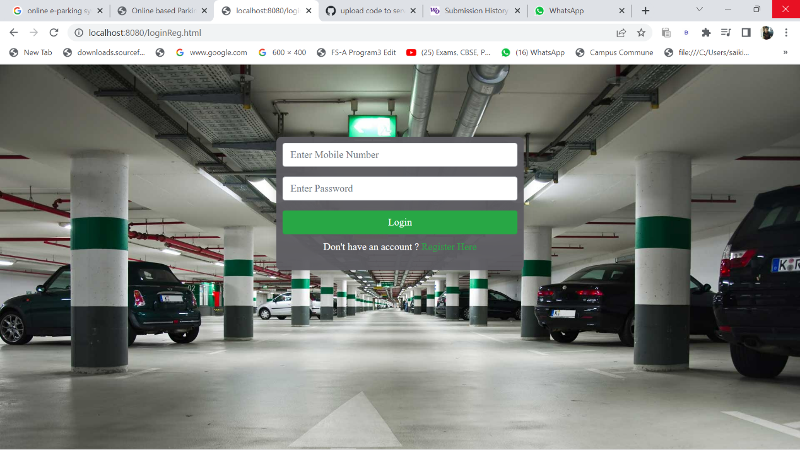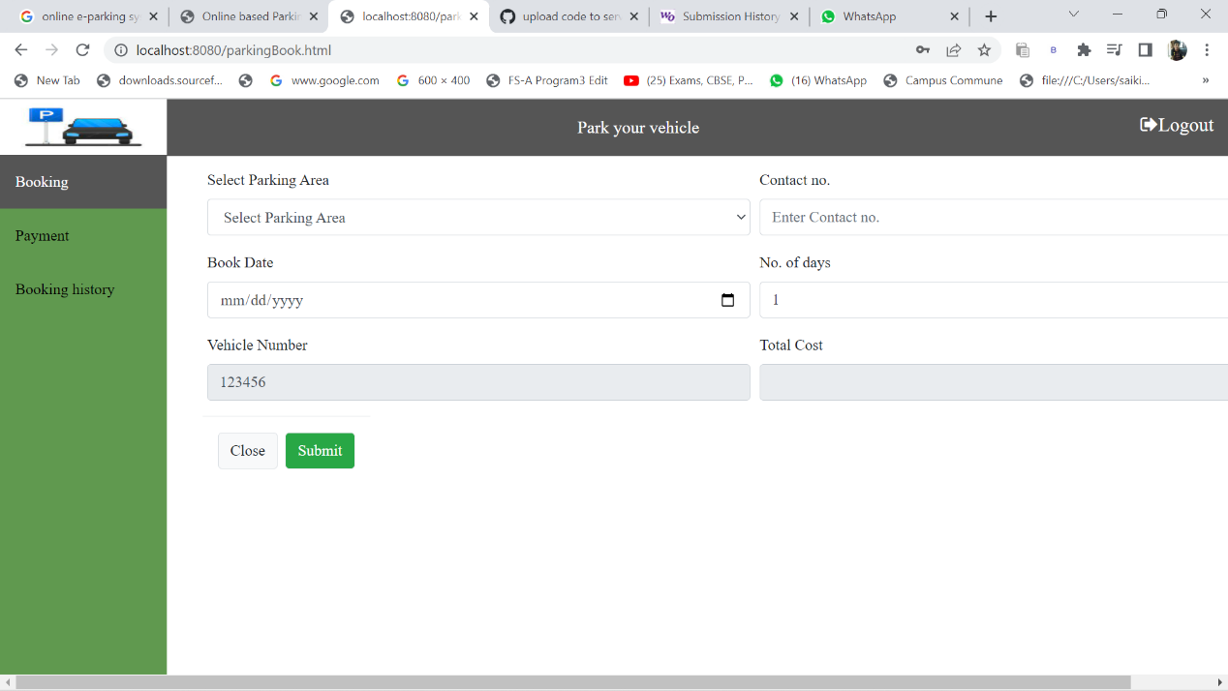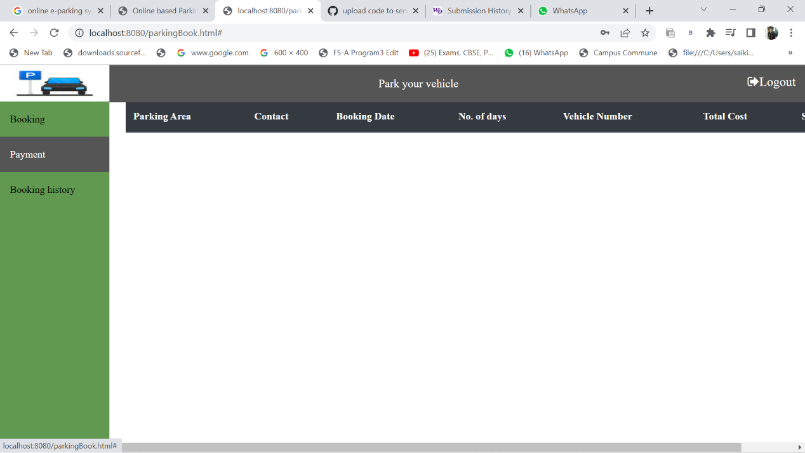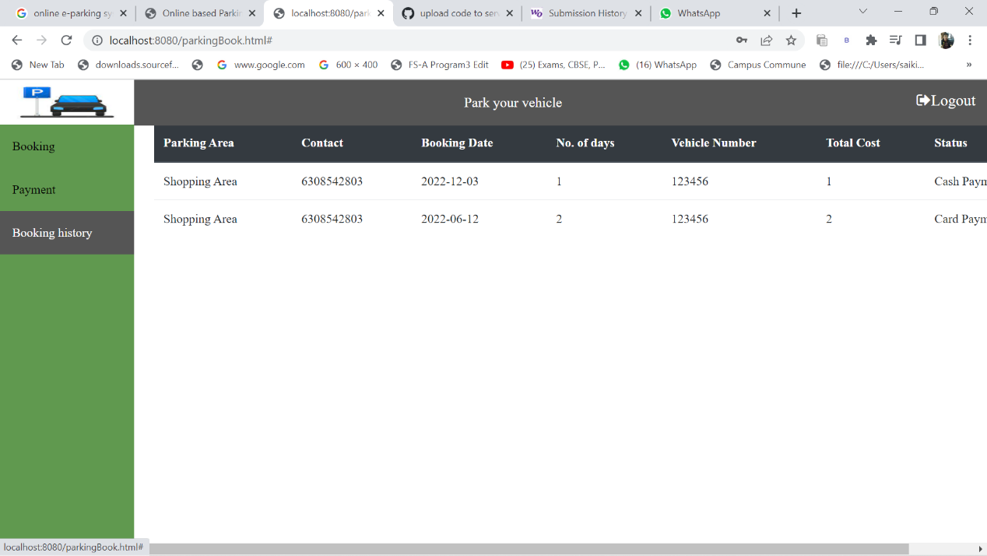

**Individual contributions made by the team**

**Manish:**

Created the project setup.

Created the signup page.

Created a page for online payment of the parking bill.

**Sai Kiran:**

Details about the parking area have been implemented.

Developed a page where users may check the parking history of their vehicles.

Created login page.

**Srujan:**

Developed a page for the parking vehicle feature.

Design a feature that allows for the change of parking area details.

Developed CSS for the project